Teaching Set 3 – Vectors that change with time
In algebra 1, you imagined the graph of $y=2x+5$ by choosing x values, plugging them in, and plotting y-values.
In this problem set the goal is to imagine how a vector changes with time in the same way. Plug in different values for time, and plot the vector at that time. Then imagine it like a flip-book animation: what’s happening to the vector?
1). Experiment 1.
Here’s a vector equation that changes with time.
$$f\left(t\right)=<\cos\left(t\right),\sin\left(t\right)>$$
Goal of this problem: See what shape path this defines and why
T | f(t) vector | Simplified | Tiny sketch of vector
0 | < cos( ___ ), sin( ___) > | < _______, _______>
$$\frac{π}{4}$$ | < cos( ___ ), sin( ___) > | < _______, _______>
$$\frac{π}{2}$$ | < cos( ___ ), sin( ___) > | < _______, _______>
$$\frac{3π}{4}$$ | < cos( ___ ), sin( ___) > | < _______, _______>
$$π$$ | < cos( ___ ), sin( ___) > | < _______, _______>
a). If the vectors are treated as position vectors, the ends of the vectors trace a path.
Complete the table and make a sketch of the path
(b). What would change if we modified the equation to be: $f\left(t\right)=<\cos\left(-t\right),\sin\left(-t\right)>$ ?

(c). What would change if we modified the equation:
$f\left(t\right)= <5, 6> + <\cos\left(t\right),\sin\left(t\right)>$ ?
What does adding the <5, 6> do to the final path?

2). Experiment 2.
What path does this trace as t ranges from $-∞<t<∞$. Let’s find out.
$f(t)$ = $<4, 3>+t⋅<-1, 2>$
Problem goal:
- What does the <4, 3> tell you about the final path?
- What does the $t⋅<-1, 2>$ tell you about the final path?
Don’t just sketch the simplified result.
Sketch the two vectors (end to end) that sum to get it.
t | Vector | Simplified result
0 | <4, 3> + _______________ | <___,___>
1 | <4, 3> + _______________ | <___,___>
2 | <4, 3> + _______________ | <___,___>
3 | <4, 3> + _______________ | <___,___>



(a). Sketch the path f(t) makes.
(b). Where would the vector tip be at $t=-1$ ? At $t=\frac{1}{2}?$
(c). What does the <4, 3> part of the original equation tell you about your path?
What does the $t⋅<-1,2>$ part of the original equation tell you about your path?

Test out your ideas:
(c). On the same axes, sketch the path: $h(t)$ = $<3, 1>+t⋅<-1, 2>$
When you changed < 4, 3 > to <3, 1 >, what changed about the path? What didn’t? Why?

(d). On the same axes, sketch the path: $h(t)$ = $<4, 3>+t⋅<5, 0>$
When you changed, <-1, 2> to <5, 0> what changed about the path? What didn’t? Why?

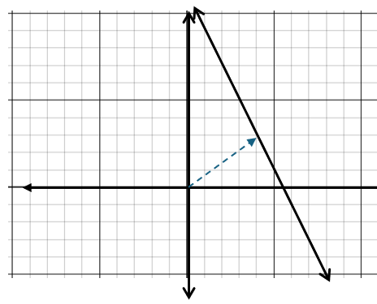
Apply and extend your Ideas
3). Change and extend your linear example
From last time, you know $f\left(t\right)=<4,3>+t⋅<-1,2>$ makes this path shown to the right.
(a). Make another vector equation for the exact same path, except start at a different point for $t=0$ and make the point move right and down as time increases.
(b). Re-write your equation from part (a) to make the point move faster.
4). More lines
a). Give a vector equation representing the line $y=-\frac{2}{3}\left(x-5\right)+3$
(you can start anywhere and move any way you like)

b). Give a vector equation for linear motion that moves from (3, 4) at t = 0 to (15, 5) at t = 1

5). Circles
a). Write a vector equation that traces out a circle of radius 5 centered at the origin.
b). Write a vector equation that traces out a circle of radius 5 centered somewhere else (you choose).
c). Trace out a circle of radius 5 centered somewhere else, but the path is clockwise (instead of anti-clockwise).

Teaching Set 3 – Vectors that change with time – Solutions
1). Experiment 1: Here’s a vector equation that changes with time. $f\left(t\right)=<\cos\left(t\right),\sin\left(t\right)>$
t | f(t) vector | Simplified | Tiny sketch of vector
0 | $$<\cos\left(0\right),\sin\left(0\right)>$$ | $$<1, 0>$$ | 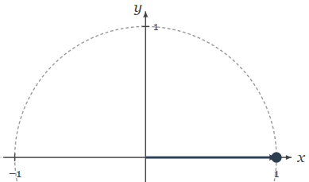
$$\frac{π}{4}$$ | $$<\cos\left(\frac{π}{4}\right),\sin\left(\frac{π}{4}\right)>$$ | $$<\frac{\sqrt{2}}{2},\frac{\sqrt{2}}{2}>$$ | 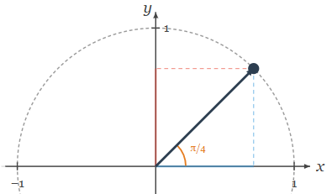
$$\frac{π}{2}$$ | $$<\cos\left(\frac{π}{2}\right),\sin\left(\frac{π}{2}\right)>$$ | $$<0, 1>$$ | 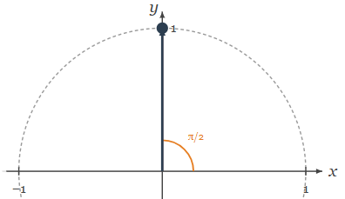
$$\frac{3π}{4}$$ | $$<\cos\left(\frac{3π}{4}\right),\sin\left(\frac{3π}{4}\right)>$$ | $$<-\frac{\sqrt{2}}{2},\frac{\sqrt{2}}{2}>$$ | 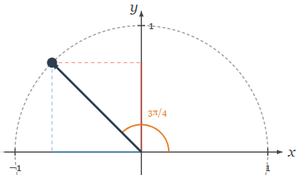
$$π$$ | $$<\cos\left(π\right),\sin\left(π\right)>$$ | $$<-1, 0>$$ | 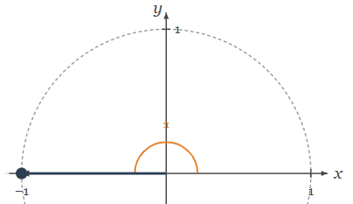
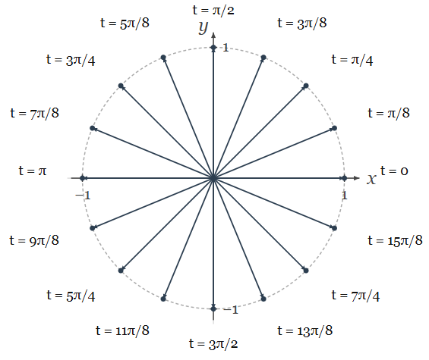
As you can see, the t in $f\left(t\right)=<\cos\left(t\right),\sin\left(t\right)>$, occupies the spot where angle usually goes. This means we’re interpreting time as the angle the vector should point at. So when time increase, the angle increases.
That means as time increase, the vector will rotate, tracing out a circular path.

(b). What would change if we modified the equation to be: $f\left(t\right)=<\cos\left(-t\right),\sin\left(-t\right)>$ ?
You could imagine plugging in values to a table just like before.
t | f(t) vector | Simplified | Tiny sketch of vector
0 | $$<\cos\left(-0\right),\sin\left(-0\right)>$$ | $$<1, 0>$$ | 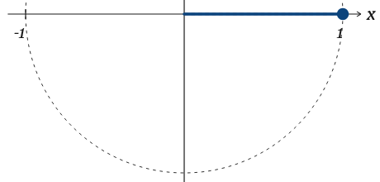
$$\frac{π}{4}$$ | $$<\cos\left(-\frac{π}{4}\right),\sin\left(-\frac{π}{4}\right)>$$ | $$<\frac{\sqrt{2}}{2},-\frac{\sqrt{2}}{2}>$$ | 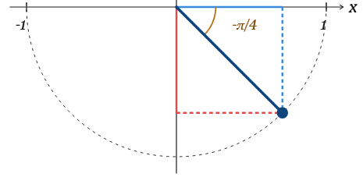
$$\frac{π}{2}$$ | $$<\cos\left(-\frac{π}{2}\right),\sin\left(-\frac{π}{2}\right)>$$ | $$<0, -1>$$ | 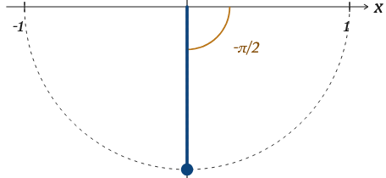
$$\frac{3π}{4}$$ | $$<\cos\left(-\frac{3π}{4}\right),\sin\left(-\frac{3π}{4}\right)>$$ | $$<-\frac{\sqrt{2}}{2},-\frac{\sqrt{2}}{2}>$$ | 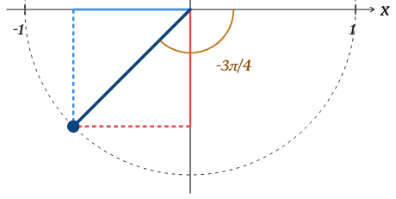
$$π$$ | $$<\cos\left(-π\right),\sin\left(-π\right)>$$ | $$<-1, 0>$$ | 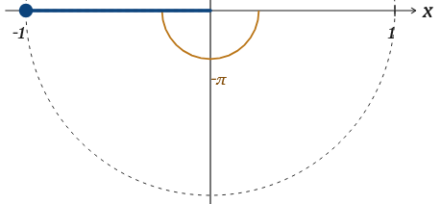

Try and see the images as an animation. As time increases, the point rotates clockwise. So changing $<\cos\left(t\right),\sin\left(t\right)>$ to $<\cos\left(-t\right),sin⁡(-t)>$ only reversed the direction of rotation. Hopefully this makes good intuitive sense, because literally we’re just reversing the angle, which means it wraps in the other direction.

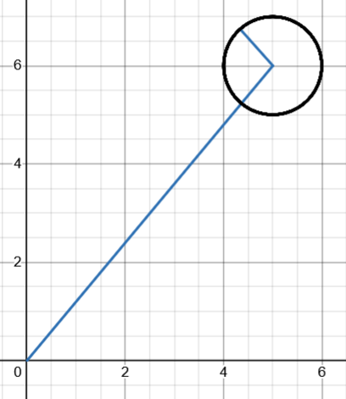
(c). What would change if we modified the equation:
$$<5, 6>$$
$$<\cos\left(t\right),\sin\left(t\right)>$$
$f\left(t\right)= <5, 6> + <\cos\left(t\right),\sin\left(t\right)>$ ?
What does adding the <5, 6 > do to the final path?
At each time, t, you start at the tip of $<5, 6>$ and add the rotating unit vector $<\cos\left(t\right),\sin\left(t\right)>$ to the end of it.
If $<\cos\left(t\right),\sin\left(t\right)>$ by itself traces out a circle, then this equation traces a circle centered at $<5, 6>$ since you start there instead of at $<0, 0>$.

2). Experiment 2.
What path does this trace as t ranges from $-∞<t<∞$. Let’s find out.
$f(t)$ = $<4, 3>+t⋅<-1, 2>$
t | Vector | Simplified result
0 | $$<4, 3>$$ | $$<4, 3>$$
1 | $$<4, 3>+<-1, 2>$$ | $$<3, 5>$$
2 | $$<4, 3>+2⋅<-1, 2>$$ | $$<2, 7>$$
3 | $$<4, 3>+3⋅<-1, 2>$$ | $$<1, 9>$$

Don’t just sketch the simplified result.
Sketch the two vectors (end to end) that sum to get it.

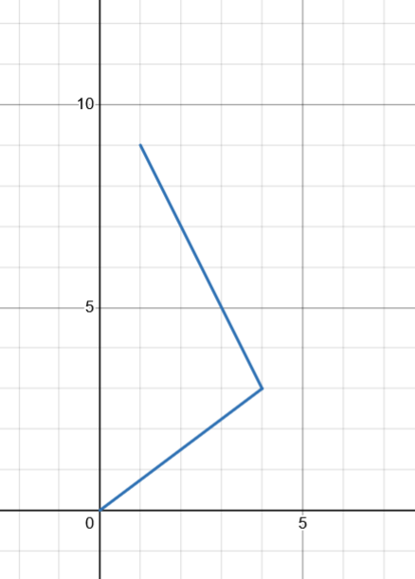
This equation defines movement at a constant speed along this linear path (the dashed line). You can see how it comes about. For all times, we start at $<4, 3>$.
$$t=0$$
$$t=1$$
$$t=2$$
$$t=3$$
$$t=\frac{1}{2}$$
$$t=-1$$
If $t=0$ that’s it. If $t=1$ we add a $<-1, 2>$ vector to the end of it. if $t=3$, we add 3 $<-1, 2>$ vectors to the end (or you could think of it as a stretched $<-1, 2>$ vector).
So, $<4, 3>$ tells you where you start on the path.
The time-scaled $<-1, 2>$ points along the direction of the path.

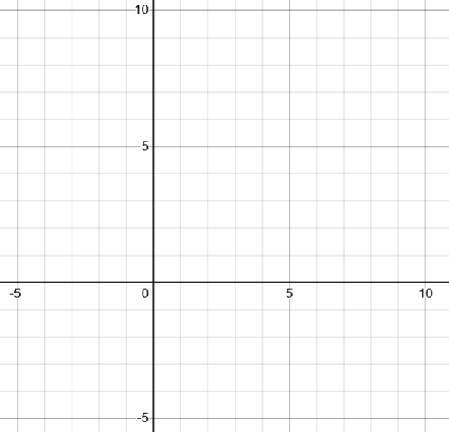
$$t=0$$
$$t=2$$
$$t=-1$$
$$t=1$$
(c). On the same axes, sketch the path: $h(t)$ = $<3, 1>+t⋅<-1, 2>$

When you changed < 4, 3 > to <3, 1 >, what changed about the path? What didn’t? Why?

I’ve left the path $<4,3>+t⋅<-1,2>$ there. You can see the new path starts at the tip of
$<3, 1>$ and moves in the direction of the vector $<-1,2>$.

That makes the path parallel to the first one since all we changed about the path was where in starts (tip of $<3,1>$ instead of tip of $<4,3>$)

(d). On the same axes, sketch the path: $h(t)$ = $<4, 3>+t⋅<5, 0>$

$$t=0$$
$$t=1$$
$$t=-1$$
When you changed, <-1, 2> to <5, 0> what changed about the path? What didn’t? Why?

Here we still start at the tip of $<4, 3>$. This time the path moves horizontally along the
$<5, 0>$ vector.

3). Change and extend your linear example

From last time, you know $f\left(t\right)=<4,3>+t⋅<-1,2>$ makes this path shown to the right.
$$t=0$$
$$t=1$$
$$t=2$$
(a). Make another vector equation for the exact same path, except start at a different point for $t=0$ and make the point move right and down as time increases.
Lots of possible solutions to this. We could start at (3, 5) and move along the vector $<2, -4>$ as shown. This equation would be $g\left(t\right)=<4,3>+t⋅<2,-4>$
(b). Re-write your equation from part (a) to make the point move faster.
To move even faster, we can move along a vector pointed in the same direction as $<2,-4>$ but one that’s longer. Then we know we’ll go in the same direction, but each time $t$ goes up by 1 we’ll go further in that direction, which means we’re going faster. For example, the equation $h\left(t\right)=<4,3>+t⋅<10, -20>$ goes 10 times as far per second as $f\left(t\right)=<4,3>+t⋅<-1, 2>$.
4). More lines
a). Give a vector equation representing the line $y=-\frac{2}{3}\left(x-5\right)+3$
I can start at any point along the line. I know $(5, 3)$ is on the line since this is point-slope form, so let’s start there.

The slope $-\frac{2}{3}$tells me how far I move up or down each time x increases by 1. So a slope of $-\frac{2}{3}$ is the same as moving along the vector $<1,-\frac{2}{3}>$. If I wanted to move faster along that same path I could move along $<3,-2>$.

So, one good solution would be $f\left(t\right)=<5, 3>+t⋅<3,-2>$.
Another would be $g\left(t\right)=<0,\frac{19}{3}>+t⋅<-6, 4>$. A test question one year was knowing how to check if a solution works, so go ahead and decide what thing you need to check to be sure this is actually the same line.

b). Give a vector equation for linear motion that moves from (3, 4) at t = 0 to (15, 5) at t = 1

I don’t need to make a cartesian equation. I start at $<3, 4>$. In one second I move from $(3,4)$ to $(15, 5)$ which is right 12 and up 1. That’s the vector $<12,1>$.

So a quick-to-find-answer is: $f\left(t\right)=<3,4>+t⋅<12,1>$

5). Circles
a). Write a vector equation that traces out a circle of radius 5 centered at the origin.
Remember that $<\cos\left(t\right),\sin\left(t\right)>$ is a length 1 rotating vector. So all we need to do is scale it to be length 5. $f\left(t\right)=5⋅<\cos\left(t\right),\sin\left(t\right)>$
b). Write a vector equation that traces out a circle of radius 5 centered somewhere else (you choose).
Let’s start by moving along $<5, 3>$ and then put the rotating vector at the tip.
$$f\left(t\right)=<5, 3>+<\cos\left(t\right), sin⁡(t)>$$
c). Trace out a circle of radius 5 centered somewhere else, but the path is clockwise (instead of anti-clockwise).
For me, the easiest way to think about rotating the other direction is to have the angle move in the other direction with time. So instead of $<\cos\left(t\right),sin⁡(t)>$ we just have $<\cos\left(-t\right),\sin\left(-t\right)>$.
The full answer is: $f\left(t\right)=<5,3>+<\cos\left(-t\right),sin⁡(-t)>$

